2 1CY681– Internet Protocol lab

Name: Akhil K J

Register Number : CYS22009

Title: Understanding Bittorrent and DHT Protocol

Date of Assignment provided: 10/12/2022

Aim: To study about bittorrent and to analyse using wireshark

1. Download the BitTorrent software from the given link https://www.bittorrent.com/.

2. Then download any one Torrent file and then save it on your device.

3. Open Wireshark in the background by choosing the appropriate interface.

* 1. 4. Then open your torrent file and start the download at least 20%. Stop the capture and document the answers to the following questions:
  2. a. Give a detailed study about the working of BitTorrent in your downloading scenario.

BitTorrent peer-to-peer (P2P) protocol finds users with files other users want and then downloads pieces of the files from those users simultaneously.  Once connected, a BitTorrent client downloads bits of the files in the torrent in small pieces, downloading all the data it can get. Once the BitTorrent client has some data, it can then begin to upload that data to other BitTorrent clients in the swarm. In this way, everyone downloading a torrent is also uploading the same torrent. This speeds up everyone’s download speed.

* 1. b. Working of BitTorrent.

1. BitTorrent is a peer-to-peer protocol, which means that the computers in a BitTorrent “swarm” (a group of computers downloading and uploading the same torrent) transfer data between each other without the need for a central server.
   1. c. Protocol Level Analysis
   2. 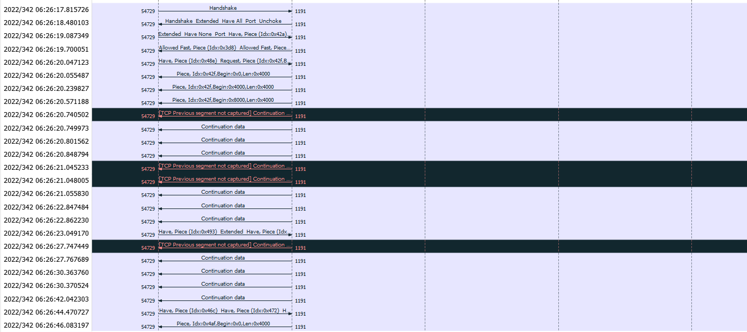
   3. 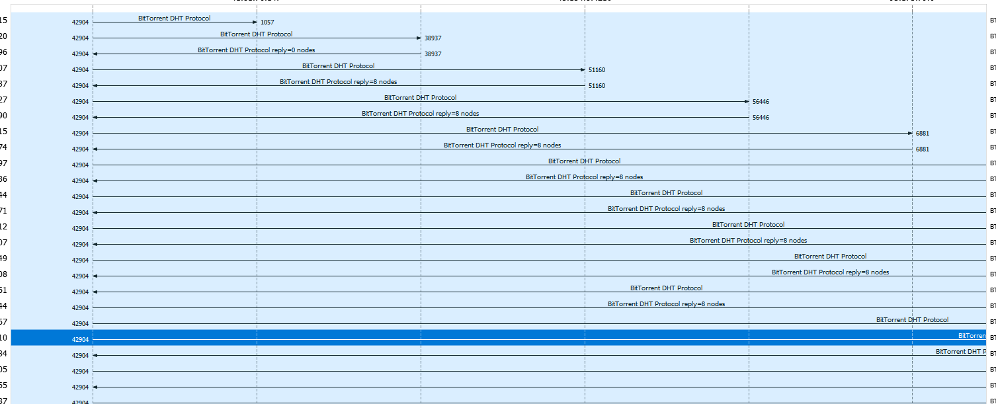
   4. d. Tracker’s status.
   5. 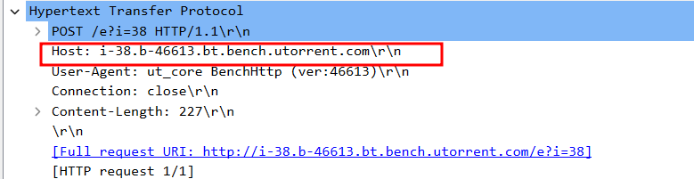
   6. e. DHT status

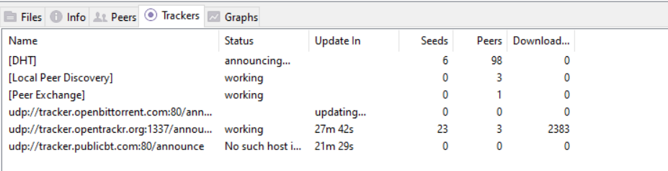

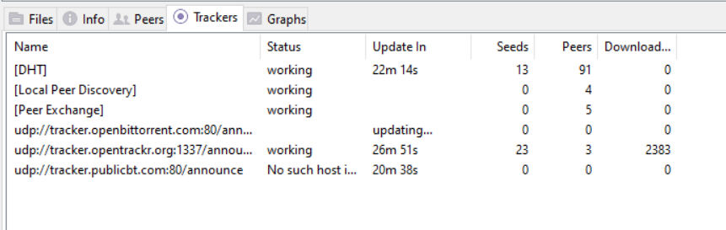

* 1. f. Identify other peers involved in the communication
  2. 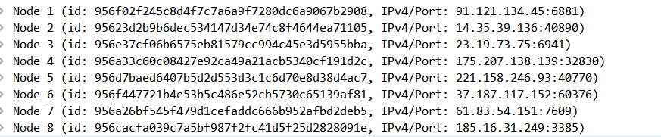
  4. g. Try to identify the name of the file downloded
  5. 
  6. 
  7. 5. Try to export the 20% of data you have captured as traffic in Wireshark while downloading files in Torrent.
  8. 6. After the Download completes and when it starts seeding, open the Wireshark and analyze the information being transferred in that traffic. Document the difference in Network traffic.

Here we didn’t get any packets for seeding. Since there wasn’t any seeding done by our system.